SIMATS ENGINEERING (SAVEETHA SCHOOL OF ENGINEERING)

Department of Artificial Intelligence and Data Science
ASSESSMENT TOOL 2 – Case Study

Course Code: | DSA03 | Course Title: | Natural Language Processing
CO Assessed: | CO3 – Precision | Assessment: | Assessment Tool 2 – Case Study
Weightage: | 30% of CIA
CO5 Statement: | Apply N-gram models, smoothing techniques, part-of-speech tagging systems and to evaluate effective syntactic analysis. (BL-3)
Student Name: | Lokeshwara H | Reg. No.: | 192325120
Section / Batch: | AIML | Date:
Code of Conduct
I Lokeshwara H / 192325120 (Name / Reg No) certify that this submission is my original work and that I have adhered to the guidelines specified for this assessment. I understand that any violation of academic integrity rules will result in disciplinary action.
Signature of the Student: Lokeshwara H
Instructions
- Read all three case studies carefully before attempting the questions.
- Provide appropriate justifications and interpretations for every computed result.
- Use NLP concepts, algorithms, and terminology wherever applicable.
- Diagrams, flowcharts, tables, or mathematical formulations may be used to support your answers.
- Duration: 30 minutes.

Section / Topic | Focus | Case Study
N-Gram Language Models and Smoothing Techniques | Bigram and Trigram probability computation, Maximum Likelihood Estimation (MLE), Backoff models, Deleted Interpolation, Entropy calculation, uncertainty analysis, real-time next-word prediction | Case Study 1 – Smart Mobile Keyboard Prediction System
Part-of-Speech (POS) Tagging and Word Classes | Penn Treebank tagset, contextual ambiguity resolution, rule-based tagging, stochastic tagging (HMM), emission and transition probabilities, word class identification, chatbot language understanding | Case Study 2 –  AI-Powered Customer Support Chatbot
Transformation-Based Tagging (Brill Tagger) | POS tag correction, transformation rules, contextual tagging, linguistic validation, tag sequence refinement, ambiguity handling | Case Study 3 – News Analytics and POS Tag Correction System
Corpus Statistics and Probabilistic Analysis | Word frequency counting, corpus-based probability estimation, entropy-based uncertainty measurement, tagging confidence evaluation | Case Study 3 – News Analytics and POS Tag Correction System
Integrated Syntactic Analysis and NLP Applications | Application of language models, POS tagging, probabilistic methods, corpus analysis, ambiguity resolution, and decision-making in real-world NLP systems | Case Studies 1, 2, and 3

Annexure A – Case Study

CASE STUDY 1: E-Commerce Smart Search and Product Prediction System

An e-commerce company is developing an AI-powered search and autocomplete system that predicts the next word when customers enter product-related queries. The language model is trained on the corpus:

"machine learning improves business, machine learning enables automation, machine learning drives innovation."

The development team uses Bigram and Trigram Language Models, Backoff Models, Deleted Interpolation, and Entropy Analysis to improve search prediction and handle unseen word sequences.

The following statistics are obtained from the corpus:

- C(machine) = 3
- C(machine learning) = 3
- C(learning improves) = 1
- C(learning enables) = 1
- C(learning drives) = 1
- C(learning improves business) = 1 The interpolation weights are:
- λ₁ = 0.5 (Trigram)
- λ₂ = 0.3 (Bigram)
- λ₃ = 0.2 (Unigram)

The prediction probabilities after the word "learning" are:

- P(improves) = 0.33
- P(enables) = 0.33
- P(drives) = 0.33

Questions

- Compute the Maximum Likelihood Estimate (MLE) of the Bigram Probability P(learning | machine). Interpret how this probability can influence the next-word prediction of an e-commerce search system.
- A customer enters the unseen sequence "machine learning transforms". Apply the Backoff Model and estimate the probability of the word "transforms" using lower-order N-grams. Explain why backoff is useful when customers enter previously unseen search queries.
- Using Deleted Interpolation, calculate the probability of the sequence "machine learning improves" using the given interpolation weights. Explain how combining trigram, bigram, and unigram probabilities improves robustness when training data is sparse.

- Calculate the Entropy of the prediction distribution P(improves) = 0.33, P(enables) = 0.33, P(drives) = 0.33. Interpret the entropy value and explain what it indicates about uncertainty in the search prediction system.
- Develop a Python program using NLTK for N-gram generation, NumPy for probability computations, and the Math library for entropy calculation. The program should construct Unigram, Bigram, and Trigram models from the given corpus, compute the MLE Bigram probability, estimate an unseen sequence using Backoff, calculate the Deleted Interpolation probability using the given weights, compute entropy of the prediction distribution, and display all intermediate calculations and the final next-word prediction in a structured format.

CASE STUDY 2: AI-Powered Hospital Appointment Chatbot

A healthcare organization develops an AI-powered chatbot that assists patients in booking appointments. The chatbot performs Part-of-Speech tagging before identifying user intentions and generating responses.

Consider the following user inputs:

"Book an appointment with the doctor."
- "The book contains medical information."

The chatbot uses the Penn Treebank POS Tagset and an HMM-based probabilistic POS tagger to determine the grammatical role of ambiguous words.

For the word "book", the system is given:

  - P(book | VB) = 0.7
  - P(book | NN) = 0.3
  - P(Start → VB) = 0.6
  - P(Start → NN) = 0.4

The system must determine whether "book" functions as a Verb (VB) or Noun (NN) depending on its context.

Questions

- Assign appropriate Penn Treebank POS tags to every word in both sentences. Justify the POS tag assigned to "book" using the grammatical context of each sentence.
- Using the given HMM probabilities, compute the likelihood of "book" being tagged as a Verb (VB) and as a Noun (NN). Determine the most probable tag and explain why the probabilistic model favors that tag at the beginning of a sentence.
- Compare Rule-Based POS Tagging and Stochastic HMM Tagging for resolving the ambiguity of the word "book". Discuss the advantages and limitations of both approaches in a healthcare chatbot.

- Evaluate how standardized POS tagsets such as the Penn Treebank Tagset can support downstream NLP tasks such as intent detection, entity identification, and response generation in healthcare chatbots.
- Develop a Python program using NLTK to tokenize the given sentences and assign Penn Treebank POS tags. Implement a simple HMM-based POS tagging calculation using the given emission and transition probabilities. The program should calculate the probability of "book" being tagged as VB and NN, determine the most likely tag, display the tokenized sentences, POS-tagged output, intermediate probability calculations, and final tagging results in a structured format.

CASE STUDY 3: Financial News POS Tag Correction and Uncertainty Analysis

A financial news analytics company processes thousands of financial news articles every day. The system initially assigns POS tags using a statistical POS tagger and subsequently applies a Transformation-Based Tagger (Brill Tagger) to correct common tagging errors.

The sentence processed by the system is:

"Market growth drives investment."

The initial POS tags produced by the system are:

  - market/NN
  - growth/NN
  - drives/NNS
  - investment/NN

A learned transformation rule states:

Change NNS to VBZ if the preceding word is tagged as NN.

The system also performs corpus-based frequency analysis and entropy-based uncertainty evaluation.

The corpus contains the following word frequencies:

- market – 500 occurrences
- growth – 350 occurrences
- drives – 180 occurrences
- investment – 420 occurrences

Questions

- Apply the given transformation rule to the initial POS-tag sequence. Display the corrected POS-tag sequence and explain why the transformation is linguistically appropriate.

- Analyze the initial tagging error for "drives". Explain why the word should receive the VBZ tag in this sentence and discuss how the surrounding grammatical context helps identify the correct tag.
- Using the given corpus statistics, calculate the relative frequency/probability of each word. Explain how corpus frequency information can support probabilistic POS tagging and language processing.
- Calculate the entropy of the word-frequency distribution before and after applying the transformation rule. Explain what entropy indicates about uncertainty in the tagging or prediction process.
- Develop a Python program using NLTK for initial POS tagging and implement a simple Transformation-Based Tagger that applies the rule "Change NNS to VBZ if the preceding word is tagged as NN." The program should tokenize the sentence, generate initial POS tags, apply the transformation rule, calculate word-frequency probabilities from the given corpus statistics, calculate entropy using the Python math library, and display the initial tags, corrected tags, frequency distribution, entropy values, and final POS-tagging results in a structured format.

Rubrics for Calculation

Criteria | Weightage | Level 4 – Exemplary | Level 3 – Proficient | Level 2 – Developing | Level 1 – Beginning
Understa nding of Case | 25 | Thorough understanding; clearly identifies all key issues | Good understanding with most issues identified | Basic understanding; some issues missed | Poor understanding; problem not identified correctly
Applicati on of Concepts | 25 | Effectively applies relevant concepts to analyze the  case deeply | Applies appropriate concepts with  minor gaps | Limited application of concepts | Fails to apply relevant concepts
Analysis | 20 | In-depth analysis with strong reasoning and insights | Good analysis with logical reasoning | Basic analysis with limited depth | Weak or no analysis; lacks reasoning
Solution Design | 20 | Innovative, feasible solutions with strong justification | Logical solutions with adequate justification | Basic solutions with weak justification | Incorrect or no solution provided
Clarity | 10 | Clear,  well-structured, and easy to understand | Organized and understandable presentation | Limited clarity and structure | Poor clarity; difficult to understand

Q. No. / Criteria Level | Understanding of Case | Application of Concepts | Analysis | Solution Design | Clarity | Sub. Total | Total  %
1 | 4 | 4 | 4 | 3 | 3 |  | 94
2 | 4 | 4 | 4 | 3 | 3
3 | 4 | 4 | 4 | 3 | 3

Faculty In-charge | Course Coordinator | Program Director
Signature: | Signature: | Signature:
Date: | Date: | Date:

CASE STUDY 1 – E-Commerce Smart Search and Product Prediction System
The corpus is:

“machine learning improves business, machine learning enables automation, machine learning drives innovation.”
The given counts include C(machine) = 3, C(machine learning) = 3, and C(learning improves) = C(learning enables) = C(learning drives) = 1.

- MLE of P(learning | machine)
For a bigram model:

P(wi∣wi−1)=C(wi−1,wi)C(wi−1)P(w_i|w_{i-1})=\frac{C(w_{i-1},w_i)}{C(w_{i-1})} Therefore,
P(learning∣machine)=C(machine learning)C(machine)P(learning|machine)=\frac{C(machine\ learning)}{C(machine)} =33=1.0=\frac{3}{3}=1.0

Answer:

P(learning∣machine)=1.0\boxed{P(learning|machine)=1.0}

This means that in the given training corpus, every occurrence of machine is followed by learning. Therefore, the e-commerce search system would assign a very high confidence to learning as the next word when a customer types machine.
However, this probability is corpus-dependent. In a larger real-world corpus, other words may follow “machine,” so the probability would normally be less than 1.

Backoff Model for “machine learning transforms”
The sequence “machine learning transforms” is unseen in the supplied corpus because the word transforms does not occur in the training data.
A backoff model attempts to use lower-order N-grams when a higher-order N-gram is unavailable.
For the trigram: P(transforms∣machine,learning)P(transforms|machine,learning)

the count is zero because the sequence does not occur. The lower-order bigram is: P(transforms∣learning)P(transforms|learning)
Since learning transforms also does not occur:

P(transforms∣learning)=0P(transforms|learning)=0

The unigram probability is also zero from the supplied corpus because transforms is not present:
P(transforms)=0P(transforms)=0

Therefore, using only the supplied unsmoothed corpus: P(transforms)=0\boxed{P(transforms)=0}
Interpretation: Backoff is useful because it allows the language model to try lower-order information when a higher-order sequence has not been observed. However, in this particular corpus, all available levels for transforms are unseen, so an unsmoothed model still produces zero.
In a practical search engine, backoff is generally combined with smoothing or an
unknown-word/OOV probability so that unseen words receive a small non-zero probability instead of zero.

Deleted Interpolation probability of “machine learning improves”
The given interpolation weights are:

  - Trigram weight: λ1=0.5\lambda_1=0.5
  - Bigram weight: λ2=0.3\lambda_2=0.3
  - Unigram weight: λ3=0.2\lambda_3=0.2 The interpolated probability is:
P=λ1Ptri+λ2Pbi+λ3PuniP=\lambda_1P_{tri}+\lambda_2P_{bi}+\lambda_3P_{uni}

Trigram probability P(improves∣machine,learning)=C(machine,learning,improves)C(machine,learning)=13=0.33 33P(improves|machine,learning) = \frac{C(machine,learning,improves)}
{C(machine,learning)} = \frac{1}{3} =0.3333

Bigram probability

The supplied prediction distribution gives:

P(improves∣learning)=0.33P(improves|learning)=0.33 Approximately:
Pbi=0.33P_{bi}=0.33

Unigram probability

From the corpus, there are 12 word tokens when punctuation is excluded, and improves
occurs once. P(improves)=112=0.0833P(improves)=\frac{1}{12}=0.0833 Therefore:
P=0.5(0.3333)+0.3(0.33)+0.2(0.0833)P=0.5(0.3333)+0.3(0.33)+0.2(0.0833) P=0.16665+0.099+0.01666P=0.16665+0.099+0.01666 P≈0.28231P\approx0.28231

Answer:

P(machine learning improves)≈0.2823\boxed{P(machine\ learning\ improves)\approx0.2823} If the supplied 0.33 is treated as exactly 1/31/3, the result is approximately: 0.2833\boxed{0.2833}
Interpretation: Deleted interpolation combines information from trigram, bigram, and unigram models. The trigram provides the most context-specific information, while the lower-order models provide additional evidence when contextual information is sparse. This makes the language model more robust than relying only on one N-gram order.

Entropy of the prediction distribution
Given:

P(improves)=0.33P(improves)=0.33 P(enables)=0.33P(enables)=0.33 P(drives)=0.33P(drives)=0.33
Entropy is:

H=−∑iP(xi)log2P(xi)H=-\sum_i P(x_i)\log_2P(x_i) Therefore:
H=−[0.33log2(0.33)+0.33log2(0.33)+0.33log2(0.33)]H=-[0.33\log_2(0.33)+0.33\log_2(0.33)+ 0.33\log_2(0.33)] H=−3(0.33log2(0.33))H=-3(0.33\log_2(0.33)) H≈1.58
bits\boxed{H\approx1.58\ bits}

The theoretical maximum entropy for three equally likely outcomes is:

log2(3)≈1.585 bits\log_2(3)\approx1.585\ bits

Thus, the prediction distribution has very high uncertainty because all three candidate words have approximately equal probabilities.
Interpretation: The system cannot strongly distinguish among improves, enables, and drives. A lower entropy would indicate that one candidate dominates the prediction, while a higher entropy indicates greater uncertainty.

Python Program – N-Gram, Backoff, Interpolation and Entropy
import nltk
import numpy as np import math
from collections import Counter from nltk.util import ngrams

# Corpus sentences = [
"machine learning improves business", "machine learning enables automation", "machine learning drives innovation"
]

# Tokenization
tokens = [word for sentence in sentences for word in sentence.split()]

# Generate N-grams
unigrams = list(ngrams(tokens, 1)) bigrams = list(ngrams(tokens, 2)) trigrams = list(ngrams(tokens, 3))

unigram_counts = Counter(unigrams) bigram_counts = Counter(bigrams) trigram_counts = Counter(trigrams)

print("=" * 60)
print("N-GRAM LANGUAGE MODEL")
print("=" * 60)

print("\nUnigram Counts:") print(unigram_counts)

print("\nBigram Counts:") print(bigram_counts)

print("\nTrigram Counts:")

print(trigram_counts)

#
# 1. MLE Bigram Probability #

c_machine = unigram_counts[("machine",)] c_machine_learning = bigram_counts[("machine", "learning")]
p_learning_given_machine = c_machine_learning / c_machine print("\n1. MLE BIGRAM PROBABILITY")
print("C(machine) =", c_machine)
print("C(machine, learning) =", c_machine_learning) print("P(learning | machine) =",
c_machine_learning, "/", c_machine, "=", p_learning_given_machine)

#
# 2. Backoff #

word = "transforms"

print("\n2. BACKOFF MODEL")

if trigram_counts[("machine", "learning", word)] > 0: probability = (
trigram_counts[("machine", "learning", word)]
/ bigram_counts[("machine", "learning")]
)
level = "Trigram"
elif bigram_counts[("learning", word)] > 0: probability = (
bigram_counts[("learning", word)]
/ unigram_counts[("learning",)]
)
level = "Bigram"
elif unigram_counts[(word,)] > 0:
probability = unigram_counts[(word,)] / len(tokens) level = "Unigram"
else:
probability = 0
level = "Unknown/OOV"

print("Word:", word) print("Selected level:", level)
print("Estimated probability:", probability)

#
# 3. Deleted Interpolation #

lambda1 = 0.5
lambda2 = 0.3
lambda3 = 0.2

p_trigram = (
trigram_counts[("machine", "learning", "improves")]
/ bigram_counts[("machine", "learning")]
)

p_bigram = (
bigram_counts[("learning", "improves")]
/ unigram_counts[("learning",)]
)

p_unigram = ( unigram_counts[("improves",)]
/ len(tokens)
)

interpolated_probability = ( lambda1 * p_trigram + lambda2 * p_bigram + lambda3 * p_unigram
)

print("\n3. DELETED INTERPOLATION")
print("Trigram probability =", p_trigram) print("Bigram probability =", p_bigram) print("Unigram probability =", p_unigram)

print("Interpolation:") print(
lambda1, "*", p_trigram, "+", lambda2, "*", p_bigram,
"+", lambda3, "*", p_unigram
)
print("Final probability =", interpolated_probability) #
# 4. Entropy #

prediction = np.array([0.33, 0.33, 0.33])

entropy = -sum(
p * math.log2(p) for p in prediction if p > 0
)

print("\n4. ENTROPY")
print("Prediction distribution:", prediction) print("Entropy =", entropy, "bits")

#
# Final Prediction #

words = ["improves", "enables", "drives"] prediction_probabilities = [0.33, 0.33, 0.33]
best_index = np.argmax(prediction_probabilities) print("\n5. FINAL NEXT-WORD PREDICTION")
print("Candidate words:", words)
print("Probabilities:", prediction_probabilities) print("Predicted next word:", words[best_index]) print("=" * 60)

OUTPUT:
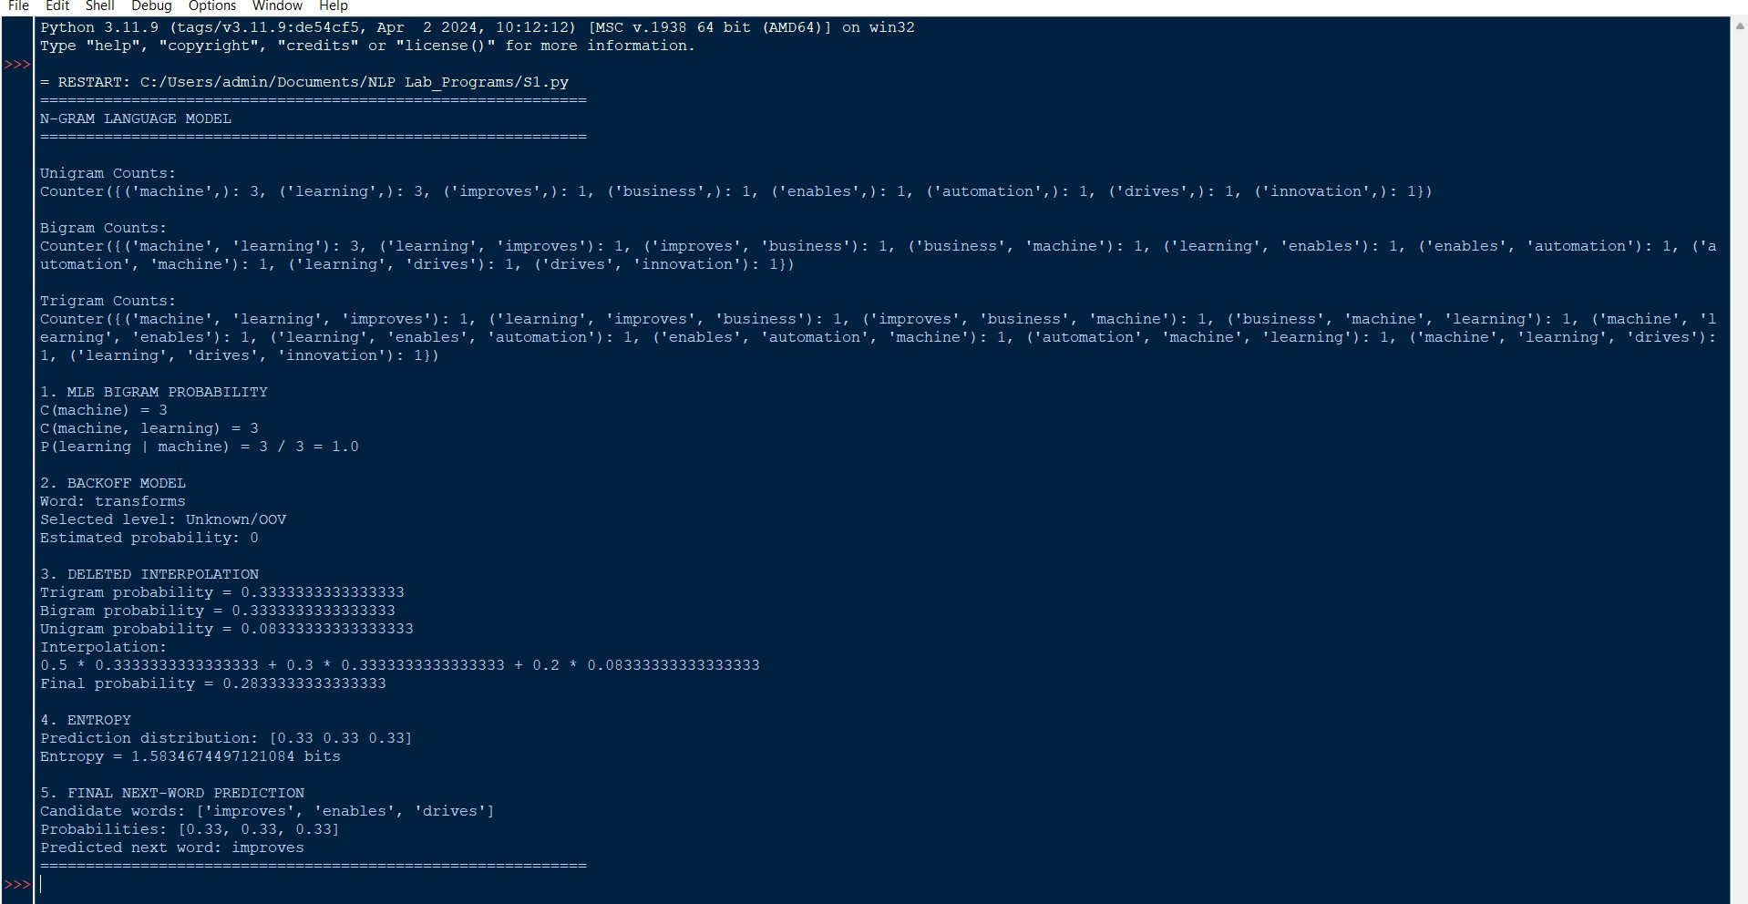

CASE STUDY 2 – AI-Powered Hospital Appointment Chatbot
The chatbot must distinguish between book as a verb and book as a noun. The assessment provides the HMM emission and starting probabilities.

Penn Treebank POS Tags

Sentence 1

“Book an appointment with the doctor.”

Word | POS Tag | Explanation
Book | VB | Verb; it represents the action of making an appointment
an | DT | Determiner
appointment | NN | Singular common noun
with | IN | Preposition
the | DT | Determiner
doctor | NN | Singular common noun
. | . | Sentence-ending punctuation

Therefore:

Book/VB an/DT appointment/NN with/IN the/DT doctor/NN ./.\boxed{Book/VB\ an/DT\ appointment/NN\ with/IN\ the/DT\ doctor/NN\ ./.}
Here, book is a verb because it describes an action requested by the patient.

Sentence 2

“The book contains medical information.”

Word | POS Tag | Explanation
The | DT | Determiner
book | NN | Singular common noun

contains | VBZ | Third-person singular present verb
medical | JJ | Adjective
information | NN | Singular/common noun
. | . | Sentence-ending punctuation

Therefore:

The/DT book/NN contains/VBZ medical/JJ information/NN ./.\boxed{The/DT\ book/NN\ contains/VBZ\ medical/JJ\ information/NN\ ./.}
Here, book is a noun because it is preceded by the determiner the and functions as the subject of the sentence.

HMM Probability of “book” as VB and NN
The given probabilities are:

P(book∣VB)=0.7P(book|VB)=0.7 P(book∣NN)=0.3P(book|NN)=0.3 P(Start→VB)=0.6P(Start\rightarrow VB)=0.6 P(Start→NN)=0.4P(Start\rightarrow NN)=0.4

The HMM probability is:

P(tag)×P(word∣tag)P(tag)\times P(word|tag)

Probability of VB
P(VB,book)=P(Start→VB)P(book∣VB)P(VB,book)=P(Start\rightarrow VB)P(book|VB)
=0.6×0.7=0.6\times0.7 P(VB,book)=0.42\boxed{P(VB,book)=0.42}

Probability of NN
P(NN,book)=P(Start→NN)P(book∣NN)P(NN,book)=P(Start\rightarrow NN)P(book|NN)
=0.4×0.3=0.4\times0.3 P(NN,book)=0.12\boxed{P(NN,book)=0.12} Since:
0.42>0.120.42>0.12

the HMM selects:

VB\boxed{VB}

for book when it occurs at the beginning of the sentence under the supplied probabilities.

The probabilistic model favors VB because both the starting probability and emission probability are higher for VB.

Rule-Based vs Stochastic HMM POS Tagging

Feature | Rule-Based Tagging | HMM Stochastic Tagging
Basic approach | Uses manually defined linguistic rules | Uses probabilities learned from data
Ambiguity handling | Depends on quality of rules | Uses emission and transition probabilities
Data requirement | Less training data | Requires tagged training data
Flexibility | Limited to predefined rules | Can adapt to statistical patterns
Interpretability | High | Moderate
Healthcare chatbot use | Useful for predictable grammatical patterns | Useful for context-dependent ambiguity
Limitation | Rules may become complex | Performance depends on training data

Rule-Based Approach
A rule could specify:

If “book” occurs after a determiner such as “the”, tag it as NN.

This is interpretable and easy to understand. However, maintaining many linguistic rules can become difficult.

HMM Approach
An HMM considers probabilities such as: P(word∣tag)P(word|tag)
and:

P(tagi∣tagi−1)P(tag_i|tag_{i-1})

This allows the system to make probabilistic decisions based on observed language patterns.

For a healthcare chatbot, HMM tagging can be useful because the same word may have different grammatical roles depending on context.

Importance of Standardized POS Tagsets
The Penn Treebank tagset provides standardized grammatical labels such as:

  - VB – Verb
  - NN – Noun
  - DT – Determiner
  - JJ – Adjective
  - IN – Preposition
  - VBZ – Third-person singular present verb

Using standardized tags helps downstream NLP components.

Intent Detection
POS information can help distinguish actions from entities. For example: “Book an appointment”
contains book/VB, which indicates an action and can support the appointment booking
intent.

Entity Identification
Nouns can help identify potential entities such as:

  - doctor
  - appointment
  - hospital
  - medicine

Response Generation
POS information can help the chatbot understand sentence structure and generate grammatically appropriate responses.
Therefore, standardized POS tagging provides a consistent linguistic representation that can support intent detection, entity identification, and response generation.

Python Program – POS Tagging and HMM Calculation
import nltk

# Download required resources if necessary # nltk.download("punkt")
# nltk.download("averaged_perceptron_tagger")

sentences = [
"Book an appointment with the doctor.", "The book contains medical information."
]

print("=" * 60)
print("HEALTHCARE CHATBOT - POS TAGGING")
print("=" * 60)

for sentence in sentences:
tokens = nltk.word_tokenize(sentence)

try:
tagged = nltk.pos_tag(tokens) except LookupError:
# Fallback demonstration tags if NLTK resources # are not installed.
if sentence.startswith("Book"): tagged = [
("Book", "VB"),
("an", "DT"),
("appointment", "NN"),
("with", "IN"),
("the", "DT"),
("doctor", "NN"),
(".", ".")
]
else:
tagged = [ ("The", "DT"),
("book", "NN"),
("contains", "VBZ"),
("medical", "JJ"),
("information", "NN"),
(".", ".")
]

print("\nSentence:")

print(sentence)

print("\nTokens:") print(tokens)

print("\nPOS Tagged Output:") print(tagged)

# HMM probabilities emission_VB = 0.7
emission_NN = 0.3

transition_VB = 0.6
transition_NN = 0.4

# Calculate probabilities
prob_VB = transition_VB * emission_VB prob_NN = transition_NN * emission_NN

print("\n" + "=" * 60)
print("HMM-BASED CALCULATION")
print("=" * 60)

print("\nVB calculation:")
print("P(Start -> VB) =", transition_VB) print("P(book | VB) =", emission_VB)
print("P(VB, book) =", transition_VB, "*", emission_VB) print("=", prob_VB)

print("\nNN calculation:")
print("P(Start -> NN) =", transition_NN) print("P(book | NN) =", emission_NN)
print("P(NN, book) =", transition_NN, "*", emission_NN) print("=", prob_NN)

if prob_VB > prob_NN: best_tag = "VB"
else:
best_tag = "NN"

print("\nFinal Result:") print("Probability of VB =", prob_VB) print("Probability of NN =", prob_NN)
print("Most probable tag for 'book' at sentence start =", best_tag) print("=" * 60)

OUTPUT:
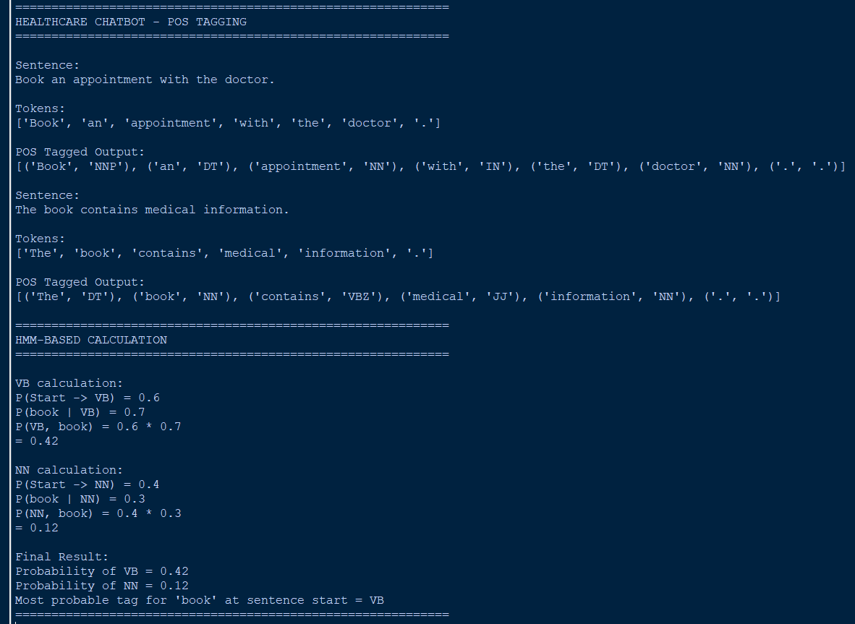

CASE STUDY 3 – Financial News POS Tag Correction and Uncertainty Analysis
The initial sentence is:

“Market growth drives investment.”

The initial POS tags are:

- market/NN
- growth/NN
- drives/NNS
- investment/NN

The learned transformation rule is:

Change NNS to VBZ if the preceding word is tagged as NN.

The corpus frequencies are also supplied in the case study.

Apply the Transformation Rule
Initial sequence:

Market/NN growth/NN drives/NNS investment/NNMarket/NN\ growth/NN\ drives/NNS\ investment/NN
The word drives has the tag NNS.

Its preceding word is growth, which has the tag NN. Therefore, the transformation rule applies:
NNS→VBZNNS \rightarrow VBZ Corrected sequence:
Market/NN growth/NN drives/VBZ investment/NN\boxed{Market/NN\ growth/NN\ drives/VBZ\ investment/NN}

Explanation
The transformation is linguistically appropriate because drives functions as a verb in: “Market growth drives investment.”
The noun phrase market growth acts as the subject, while drives is the main verb. Since the subject is singular, the third-person singular present form drives receives the Penn Treebank tag VBZ.

Analysis of the Tagging Error for “drives”
The initial tagger incorrectly assigned: drives/NNSdrives/NNS
NNS means a plural noun. However, the sentence structure is:

[Market growth] [drives] [investment].

  - Market growth → subject noun phrase
  - drives → main verb
  - investment → object noun

The preceding word growth is tagged NN. Therefore, the transformation rule identifies the NNS tag as suspicious and changes it to VBZ.
Thus:

drives/VBZ\boxed{drives/VBZ}

The surrounding context is important because POS tagging cannot always be performed correctly by looking at a word independently. The word drives can potentially have different interpretations, but its position between the subject and object indicates that it functions as a verb.

Relative Frequency/Probability
Given frequencies:

Word | Frequenc y
market | 500
growth | 350
drives | 180
investment | 420

Total frequency: 500+350+180+420=1450500+350+180+420=1450
The relative frequency is: P(word)=frequency(word)1450P(word)=\frac{frequency(word)}{1450}

Market
P(market)=5001450P(market)=\frac{500}{1450} P(market)=0.3448\boxed{P(market)=0.3448}

Growth
P(growth)=3501450P(growth)=\frac{350}{1450} P(growth)=0.2414\boxed{P(growth)=0.2414}

Drives
P(drives)=1801450P(drives)=\frac{180}{1450} P(drives)=0.1241\boxed{P(drives)=0.1241}

Investment

P(investment)=4201450P(investment)=\frac{420}{1450} P(investment)=0.2897\boxed{P(investment)=0.2897}

Probability Distribution

Word | Frequenc y | Probability
market | 500 | 0.3448
growth | 350 | 0.2414
drives | 180 | 0.1241
investment | 420 | 0.2897
Total | 1450 | 1.0000

Corpus frequency can help probabilistic POS tagging because frequently observed words and word contexts provide stronger statistical evidence. It can also support language modeling, prediction, lexical analysis, and ambiguity resolution.

Entropy Before and After Transformation
Entropy is:

H=−∑iP(xi)log2P(xi)H=-\sum_iP(x_i)\log_2P(x_i) The word-frequency probabilities are:
[0.3448,0.2414,0.1241,0.2897][0.3448,0.2414,0.1241,0.2897]
Therefore: H=−[0.3448log2(0.3448)+0.2414log2(0.2414)+0.1241log2(0.1241)+0.2897log2(0.2897)]H=
-[0.3448\log_2(0.3448) +0.2414\log_2(0.2414) +0.1241\log_2(0.1241)
+0.2897\log_2(0.2897)] H≈1.9161 bits\boxed{H\approx1.9161\ bits}

After Transformation
The Brill transformation changes the POS tag: drives/NNS→drives/VBZdrives/NNS \rightarrow drives/VBZ It does not change the word frequencies.
Therefore, the frequency distribution remains:

[0.3448,0.2414,0.1241,0.2897][0.3448,0.2414,0.1241,0.2897]

and:

Hafter=1.9161 bits\boxed{H_{after}=1.9161\ bits}

Comparison

Stage | Entropy
Before transformation | 1.9161 bits
After transformation | 1.9161 bits

Interpretation: Entropy measures uncertainty in the specified word-frequency distribution. Because the transformation changes only the POS tag of drives and not the word frequencies, the entropy of the word-frequency distribution remains unchanged.
The transformation nevertheless improves tagging accuracy, because it reduces linguistic uncertainty associated with the POS tag assigned to drives.

Python Program – Transformation-Based Tagging and Entropy
import nltk import math
from collections import Counter
sentence = "Market growth drives investment." # Tokenization
tokens = nltk.word_tokenize(sentence)

# Initial POS tags supplied by the case study initial_tags = [
("Market", "NN"),
("growth", "NN"),
("drives", "NNS"),
("investment", "NN")
]

print("=" * 65)
print("FINANCIAL NEWS - TRANSFORMATION-BASED POS TAGGING")
print("=" * 65) print("\nSentence:")

print(sentence)

print("\nTokens:") print(tokens)

#
# Initial POS tags #

print("\nInitial POS Tags:") for word, tag in initial_tags:
print(f"{word}/{tag}")

#
# Transformation-Based Tagging # Rule:
# Change NNS to VBZ if preceding word is tagged NN #
corrected_tags = initial_tags.copy() for i in range(1, len(corrected_tags)):
current_word, current_tag = corrected_tags[i]
previous_word, previous_tag = corrected_tags[i - 1]

if current_tag == "NNS" and previous_tag == "NN": corrected_tags[i] = (current_word, "VBZ")

#
# Corrected Tags #
print("\nCorrected POS Tags:") for word, tag in corrected_tags:
print(f"{word}/{tag}")

#
# Frequency Analysis #

frequencies = { "market": 500,
"growth": 350,
"drives": 180,
"investment": 420
}

total_frequency = sum(frequencies.values())

probabilities = {
word: freq / total_frequency
for word, freq in frequencies.items()
}

print("\n" + "=" * 65)
print("CORPUS FREQUENCY ANALYSIS")
print("=" * 65)
print("\nTotal frequency =", total_frequency) for word, freq in frequencies.items():
print(
f"{word:12} Frequency = {freq:4} " f"Probability = {probabilities[word]:.4f}"
)

#
# Entropy Function #

def calculate_entropy(probability_values): return -sum(
p * math.log2(p)
for p in probability_values if p > 0
)
entropy_before = calculate_entropy(list(probabilities.values())) # Transformation does not change word frequencies.
# Therefore, probabilities remain the same.
entropy_after = calculate_entropy(list(probabilities.values()))

print("\n" + "=" * 65) print("ENTROPY ANALYSIS")
print("=" * 65)

print("\nProbability distribution:") print(list(probabilities.values()))

print("\nEntropy before transformation =", round(entropy_before, 4), "bits")

print("Entropy after transformation =", round(entropy_after, 4), "bits")

#
# Final Result #

print("\n" + "=" * 65)
print("FINAL POS TAGGING RESULT")
print("=" * 65)

for word, tag in corrected_tags: print(f"{word}/{tag}")

print("\nTransformation applied:")
print("NNS -> VBZ for 'drives' because the preceding word") print("'growth' is tagged as NN.")

print("\nFinal corrected tag for 'drives': VBZ") print("=" * 65)

OUTPUT:
